Title

subtitle

Author(s) name, email address, student id, educational program

*Abstract*—Add a short abstract here containing at most 100 words. Abstracts do not contain symbols, special characters, math, or references. Describe the context shortly, and summarize the research question and the main items from the discussion.

*Index Terms*—four key words in alphabetical order, separated by commas.

# INTRODUCTION

The introduction contains (1) a background, (2) the definition of the problem that is addressed possibly with a research question and subquestions, (3) a short outline of the report.

Note 1: the problem is **not** how to create a Matlab function. The definition of the problem should be at a much higher level of abstraction.

Note 2: The introduction should be readable for a less technically skilled audience, e.g. a clinician, or a manager. Therefore, the introduction does not contain symbols, special characters, or math.

# Methods and materials

## Materials

A short inventory of what has been used.

## Methods

*1) Analysis:* Start with defining the overview of the problem in a more mathematical context. What is the input? What is the desired output? (Introduce mathematical symbols for the input and output variables). What is in rough steps the strategy to get the output from the input?

Next, define the subtasks in more detail. For each subtask, introduce variables whenever needed, and set-up the mathematical relations (equations) between these variables (possibly combined with pseudo code). Do **not** use Matlab code. Describe your algorithm such that the principle of operation becomes clear. For that, use ‘mathematical style’ pseudo code. See: <https://en.wikipedia.org/wiki/Pseudocode> and pseudo-code examples provided in [https://en.wikipedia.org/wiki/Category:Articles_with_example _pseudocode](https://en.wikipedia.org/wiki/Category:Articles_with_example_pseudocode). The only place in the report that contains Matlab code is the appendix (you should add your listing as an annex).

*2) Performance evaluation:* For a performance evaluation, you often need to set-up an experiment. Describe the (protocol of the) experiment. Describe how the outcome of the experiment will be processed. Often, you need reference values, i.e. a gold standard, or a ground truth. Describe how this is achieved. If the processing is done statistically, mention the statistical test or statistical inference method.

# Results

Here, you give the results of what is described in Section II: tables, images and/or graphs. The accompanying text of these tables, images and/or graphs clarifies how they are related to the methods described in Section II.

If you have any remarkable observations, mention and describe them here, but without an interpretation, explanation, or meaning. Do not introduce new methods in this section. And do not give an interpretation or a judgement of these results.

# Discussion

Give an interpretation and judgement of the results. If you had any remarkable observations, discuss them here to give them meaning (interpretation, explanation, implication).

Describe limitations of the study. If applicable, compare your results with results from literature. If applicable, provide recommendations for further work.

# Conclusion

A conclusion reviews the main points of the paper. Describe the overall implication of the results to the original problem statement (or research questions). Do not replicate the abstract as the conclusion. A conclusion might also elaborate on the importance of the work, or suggest applications.

Appendix A

Guidelines for formatting Math

If you are using *Word,* use either the Microsoft Equation Editor or the *MathType* add-on (<http://www.mathtype.com>) for equations in your paper.

Number equations consecutively with equation numbers in parentheses flush with the right margin, as in (1). Punctuate equations when they are part of a sentence, as in

 (1)

Be sure that the symbols in your equation have been defined before the equation appears or immediately following. Italicize symbols (*T* might refer to temperature, but T is the unit tesla). Refer to “(1),” not “eq. (1)” or “equation (1),” except at the beginning of a sentence: “Equation (1) is ... .”

Appendix B

TABLE I

Units for Magnetic Properties

|  |  |  |
| --- | --- | --- |
| Symbol | Quantity | Conversion from Gaussian and  CGS EMU to SI a |
| Φ | magnetic flux | 1 Mx → 10−8 Wb = 10−8 V·s |
| *B* | magnetic flux density,  magnetic induction | 1 G → 10−4 T = 10−4 Wb/m2 |
| *H* | magnetic field strength | 1 Oe → 103/(4π) A/m |
| *m* | magnetic moment | 1 erg/G = 1 emu  → 10−3 A·m2 = 10−3 J/T |
| *M* | magnetization | 1 erg/(G·cm3) = 1 emu/cm3  → 103 A/m |
| 4π*M* | magnetization | 1 G → 103/(4π) A/m |
| σ | specific magnetization | 1 erg/(G·g) = 1 emu/g → 1 A·m2/kg |
| *j* | magnetic dipole  moment | 1 erg/G = 1 emu  → 4π × 10−10 Wb·m |
| *J* | magnetic polarization | 1 erg/(G·cm3) = 1 emu/cm3  → 4π × 10−4 T |
| χ*,* κ | susceptibility | 1 → 4π |
| χρ | mass susceptibility | 1 cm3/g → 4π × 10−3 m3/kg |
| μ | permeability | 1 → 4π × 10−7 H/m  = 4π × 10−7 Wb/(A·m) |
| μr | relative permeability | μ → μr |
| *w, W* | energy density | 1 erg/cm3 → 10−1 J/m3 |
| *N, D* | demagnetizing factor | 1 → 1/(4π) |

Vertical lines are optional in tables.

Guidelines for Graphs, Tables, Videos, and References

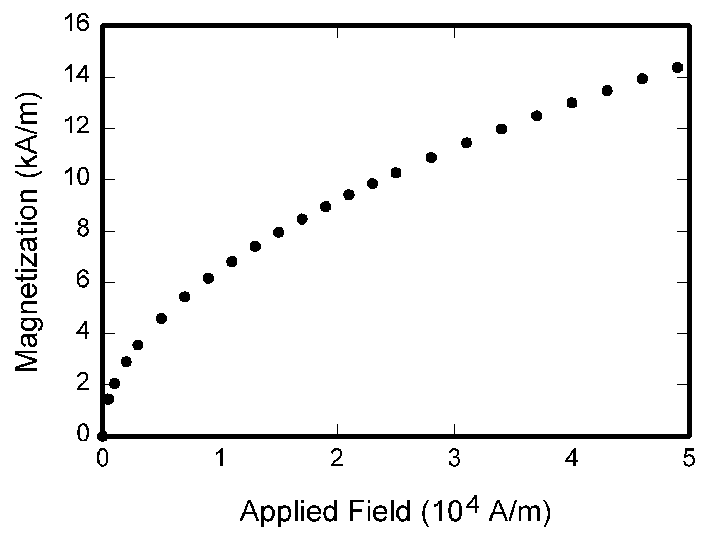

Fig. 1. Magnetization as a function of applied field. Note that “Fig.” is abbreviated. There is a period after the figure number, followed by two spaces. It is good practice to explain the significance of the figure in the caption.

*1) Graphs and Images:* Below each figure (graph or image) there must be a caption with a figure number and a figure title. See Fig 1. Figure titles should be legible, approximately 8 to 10 point type. Each figure should be referenced in the text. Each axis of a graph should have a label. Use words rather than symbols. As an example, write the quantity “Magnetization,” or “Magnetization *M*,” not just “*M*.” Put units in parentheses. Do not label axes only with units. As in Fig. 1, for example, write “Magnetization (A/m)” or “Magnetization (Am−1),” not just “A/m.”

2) *Tables:* Tables should have a table caption on top. See Table I. Tables should be numbered with Roman Numerals (I, II, III, IV, and so on). Tables should also always be referenced in the text.

*3) Videos:* Videos should be uploaded as separate files. The preferred video format is mp4. Don’t make the video files unnecessarily large. 20 Mbytes is acceptable, but 200 Mbyte is not. Appendix A contains a Matalb script that you can use to resize the frame size of a video. The parameter *quality* controls the amount of compression. Sometimes it is also useful to skip frames. For instance, only write the odd frames to the output video.

*4) References:* In text, refer simply to the reference number. Do not use “Ref.” or “reference” except at the beginning of a sentence: “Reference [3] shows ... .”

Appendix C

Matlab script for resizing a video

%% convert a video

clear variables

close all

inputname = 'input_name.mp4';

outputname = 'output_name.mp4';

profile = 'MPEG-4';

framerate = 25;

quality = 75;

resize = 1; % resizing needed?

width = 640; % if so, this the new width

height = 480; % and this is the new height

crop = 0; % cropping needed?

croprect = [ 142 36 563 672];

obj = VideoReader(inputname);

nFrames = obj.NumberOfFrames;

wobj = VideoWriter(outputname,profile);

wobj.FrameRate = framerate;

wobj.Quality = quality;

open(wobj);

% Read and write one frame at a time.

hwait = waitbar(0);

k = 1;

while hasFrame(obj)

im = readframe(obj);

if crop % crop if wanted

im = imcrop(im,croprect);

end

if resize % resize if wanted

im = imresize(im,[height width]);

end

writeVideo(wobj,im);

if mod(k,10)==1, waitbar(k/nFrames,hwait); end

k = k+1;

end

delete(hwait);

close(wobj)

References

*Basic format for books:*

1. J. K. Author, “Title of chapter in the book,” in *Title of His Published Book, x*th ed. City of Publisher, Country if not USA: Abbrev. of Publisher, year, ch. *x*, sec. *x*, pp. *xxx–xxx.*

*Examples:*

1. G. O. Young, “Synthetic structure of industrial plastics,” in *Plastics,* 2nd ed., vol. 3, J. Peters, Ed. New York: McGraw-Hill, 1964, pp. 15–64.
2. W.-K. Chen, *Linear Networks and Systems.* Belmont, CA: Wadsworth, 1993, pp. 123–135.

*Basic format for periodicals:*

1. J. K. Author, “Name of paper,” *Abbrev. Title of Periodical*, vol. *x,* no. *x,* pp*. xxx-xxx,* Abbrev. Month, year.

*Examples:*

1. J. U. Duncombe, “Infrared navigation—Part I: An assessment   
   of feasibility,” *IEEE Trans. Electron Devices*, vol. ED-11, no. 1, pp. 34–39, Jan. 1959.

*Basic format for reports:*

1. J. K. Author, “Title of report,” Abbrev. Name of Co., City of Co., Abbrev. State, Rep. *xxx*, year.

*Examples:*

1. E. E. Reber, R. L. Michell, and C. J. Carter, “Oxygen absorption in the earth’s atmosphere,” Aerospace Corp., Los Angeles, CA, Tech. Rep. TR-0200 (4230-46)-3, Nov. 1988.

*Basic format for books (when available online):*

1. Author. (year, month day). *Title.* (edition) [Type of medium]. *volume (issue).* Available: site/path/file

*Example:*

1. J. Jones. (1991, May 10). *Networks.* (2nd ed.) [Online]. Available: [http://www.atm.com](http://www.atm.com/)

*Basic format for journals (when available online):*

1. Author. (year, month). Title. *Journal.* [Type of medium]. *volume (issue),* pages. Available: site/path/file

*Example:*

1. R. J. Vidmar. (1992, Aug.). On the use of atmospheric plasmas as electromagnetic reflectors. *IEEE Trans. Plasma Sci.* [Online]. *21(3),* pp. 876–880. Available:<http://www.halcyon.com/pub/journals/21ps03-vidmar>

*Basic format for papers presented at conferences (when available online):*

1. Author. (year, month). Title. Presented at Conference title. [Type of Medium]. Available: site/path/file

*Example:*

1. PROCESS Corp., MA. Intranets: Internet technologies deployed behind the firewall for corporate productivity. Presented at   
   INET96 Annual Meeting. [Online]. Available: <http://home.process.com/Intranets/wp2.htp>

*Basic format for conference proceedings (published):*

1. J. K. Author, “Title of paper,” in *Abbreviated Name of Conf.*, City of Conf., Abbrev. State (if given), year, pp. *xxxxxx.*

*Example:*

1. D. B. Payne and J. R. Stern, “Wavelength-switched pas- sively coupled single-mode optical network,” in *Proc. IOOC-ECOC,* 1985,   
   pp. 585–590.

*Example for papers presented at conferences (unpublished):*

1. D. Ebehard and E. Voges, “Digital single sideband detection for interferometric sensors,” presented at the 2nd Int. Conf. Optical Fiber Sensors, Stuttgart, Germany, Jan. 2-5, 1984.

*Basic format**for theses (M.S.) and dissertations (Ph.D.):*

1. J. K. Author, “Title of thesis,” M.S. thesis, Abbrev. Dept., Abbrev. Univ., City of Univ., Abbrev. State, year.
2. J. K. Author, “Title of dissertation,” Ph.D. dissertation, Abbrev. Dept., Abbrev. Univ., City of Univ., Abbrev. State, year.

*Examples:*

1. J. O. Williams, “Narrow-band analyzer,” Ph.D. dissertation, Dept. Elect. Eng., Harvard Univ., Cambridge, MA, 1993.
2. N. Kawasaki, “Parametric study of thermal and chemical nonequilibrium nozzle flow,” M.S. thesis, Dept. Electron. Eng., Osaka Univ., Osaka, Japan, 1993.